Google Ranking With Blog Post Complete Solution.

The Blog Post is divided into 6 Parts
- Google Keywords Research
- Semrush Magic Keyword Tool
- Semrush AI Prompt Topics & Examples
- Clustering
- SEO Search Engine Optimization
- How To Write A Blog With AI

Google Keywords Research
In this research, we need to explore all the keywords that are related to our product or service. To do this, we need to use the Google Keyword Planner tool free for everyone; we just need to set up our ad account.

Note: Do not target keywords that have very high monthly search volume; just check for those keywords that are in medium demand.

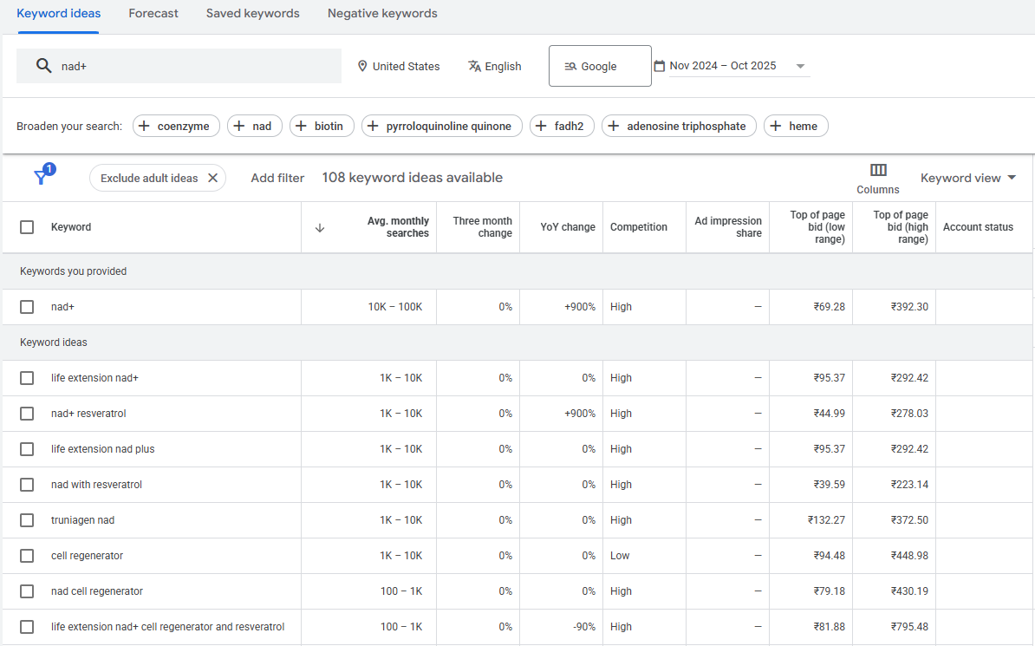
In the above image, we take an example of the Circle of Nature NAD+ Supplement product. This product helps in anti-aging, cell regeneration, and mitochondrial health. And we are doing Google keyword research on that.
Semrush Magic Keyword Tool
In this section, we mainly need to check the keyword difficulty and the intent of the keyword. In this research, we need to choose the minimum keyword difficulty word with little search volume. And then we can match that keyword with our Google Keyword Planner Report.

Intents are of three types: Informational, which means customers are searching for a particular keyword to get knowledge, and other sellers are also focusing on this keyword for informational purposes. In this user wants to find an answer to a specific question.

Second commercial, these are the keywords that other sellers are using to advertise their product or service. The main motive of this keyword is to get maximum sales. In this user wants to investigate brands or services.
The third one is transnational, and these are both commercial and informational; consumers may buy your product.

Note: These are the ways of writing a blog. A particular keyword can be commercial/information/transactional, and mixed.

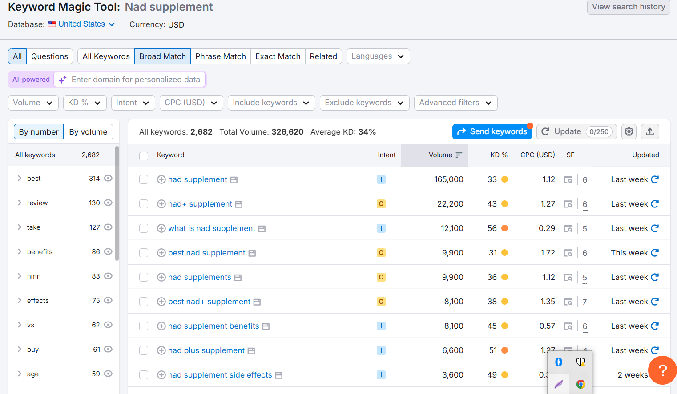
In the screenshot, I have been trying to find the best keyword with low difficulty and medium search volume. To compare with my Google keyword report.

Semrush AI Prompt Topics & Examples
In this Part, we need to search for prompts that people are using to search on ChatGPT, Google AI, and other AI platforms. Basically, this is for when anyone searches on an AI tool about a nad supplement. In that case tool like ChatGPT recommends our brand and product. In this, we can also check what response Google AI is giving to the user, and according to that, we can modify our Blog. This is just for reference so that we can build a good topic for our blog, which is very important.

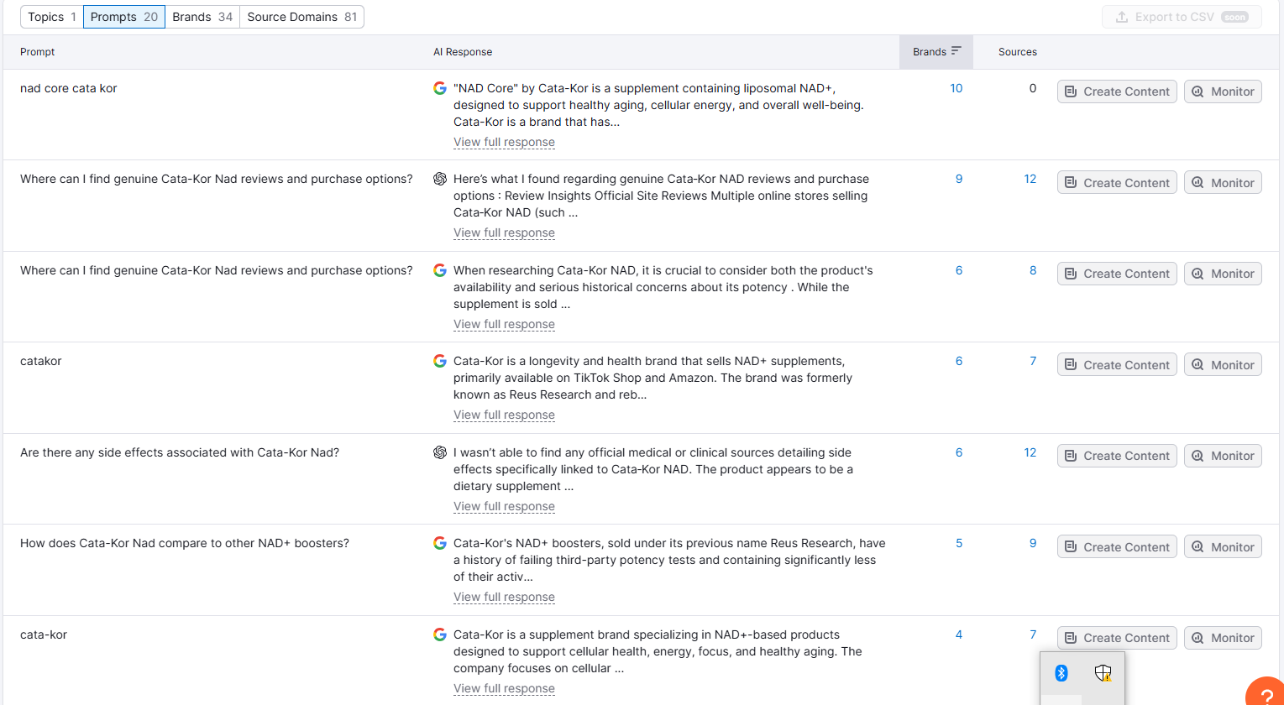
In the example, you can see that I am searching for the topics and content that AI gives to the user; either I can make a whole topic, or I can update it in the FAQ section. Sometimes the whole keyword is the topic of the blog.

Clustering
In this part, we need to strategically build a clustering for our blog topic with the above research. We will get to know about now to start, and which topics and keywords to select. But in this step, we are going to learn how we can make it practically live. I personally called this section the brain for Google ranking.

In this part, we need to arrange all our collected topics and keywords very synergy and strategically in one row. Example Link

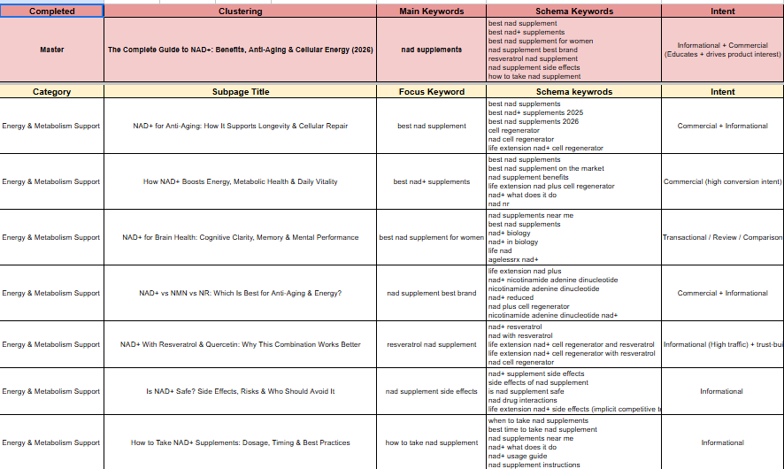
In the example image, you can see that my topics are arranged according to the keyword targeting with their synonyms, keywords, or similar keywords. For better clarity in this cluster in the bottom, I made a topic called How to Take NAD+ Supplements: Dosage, Timing & Best Practices, and the focusing keyword is how to take NAD+ supplements. When I write a blog on this topic, with targeted words with SEO. Google will know that for this keyword, the topic is this, and you can find it on this brand website. Then we can add a banner like a CTA to our product directly in the blog.

SEO: Search Engine Optimization
In this part, we are doing Technical SEO for our blog page. In the backend of WordPress/Shopify, we need to fill the portion of named Meta title, Meta description, focus keyword, URLHandle(Slug), Synonyms of the keywords related to our topic, Social title, social description, Along with that all the images that we are using in the blog have field like ALT text, image title, image caption, image description. Make sure to include all these columns at the backend of the website.

Note: URL slug should always be short, or you can put the focus keyword as url handle(slug). Never use a number in url.

Use Schema in every Blog page so that Google knows your faq’s related to the blog and also keywords. All the FAQ’s that you are using in the blog must be in schema.
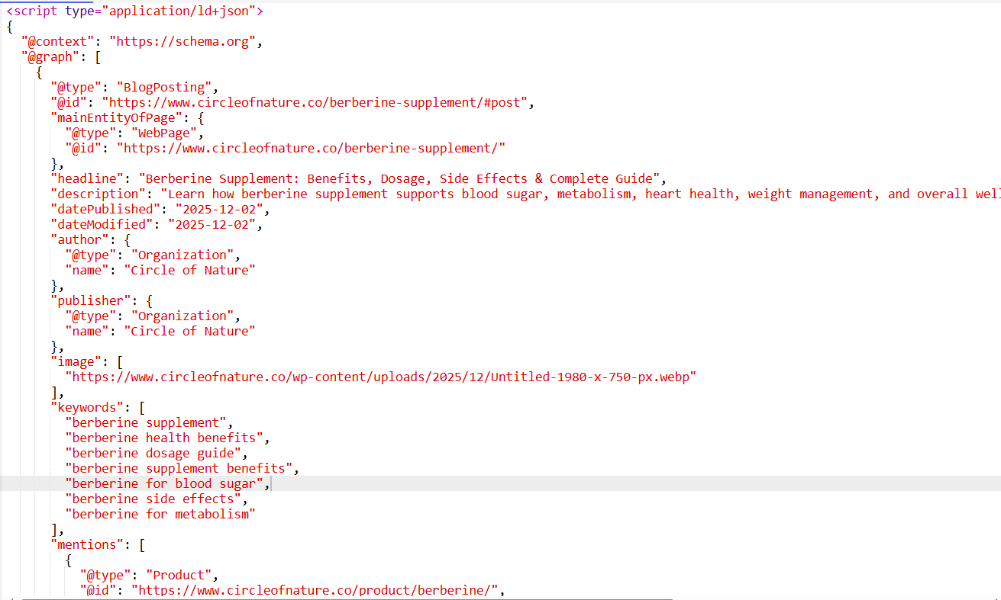
Below is the example code of the schema on how to write according to Google
<script type="application/ld+json">
{
"@context": "https://schema.org",
"@graph": [
{
"@type": "BlogPosting",
"@id": "https://www.circleofnature.co/berberine-supplement/#post",
"mainEntityOfPage": {
"@type": "WebPage",
"@id": "https://www.circleofnature.co/berberine-supplement/"
},
"headline": "Berberine Supplement: Benefits, Dosage, Side Effects & Complete Guide",
"description": "Learn how berberine supplement supports blood sugar, metabolism, heart health, weight management, and overall wellness. Science-backed benefits, dosage, and safety guide.",
"datePublished": "2025-12-02",
"dateModified": "2025-12-02",
"author": {
"@type": "Organization",
"name": "Circle of Nature"
},
"publisher": {
"@type": "Organization",
"name": "Circle of Nature"
},
"image": [
"https://www.circleofnature.co/wp-content/uploads/2025/12/Untitled-1980-x-750-px.webp"
],
"keywords": [
"berberine supplement",
"berberine health benefits",
"berberine dosage guide",
"berberine supplement benefits",
"berberine for blood sugar",
"berberine side effects",
"berberine for metabolism"
],
"mentions": [
{
"@type": "Product",
"@id": "https://www.circleofnature.co/product/berberine/",
"name": "Circle of Nature Berberine Supplement"
}
]
},
{
"@type": "FAQPage",
"@id": "https://www.circleofnature.co/berberine-supplement/#faq",
"mainEntity": [
{
"@type": "Question",
"name": "What is berberine supplement?",
"acceptedAnswer": {
"@type": "Answer",
"text": "Berberine is a natural compound derived from plants that supports blood sugar, metabolism, inflammation reduction, and overall metabolic health."
}
},
{
"@type": "Question",
"name": "What are the benefits of berberine?",
"acceptedAnswer": {
"@type": "Answer",
"text": "Berberine supports healthy blood sugar, weight management, cholesterol balance, heart health, inflammation control, and improved insulin sensitivity supported by clinical studies."
}
},
{
"@type": "Question",
"name": "How much berberine should I take daily?",
"acceptedAnswer": {
"@type": "Answer",
"text": "Most studies recommend 900–1500mg daily, divided into 2–3 doses with meals for best absorption and fewer digestive side effects."
}
},
{
"@type": "Question",
"name": "What are the side effects of berberine?",
"acceptedAnswer": {
"@type": "Answer",
"text": "Common side effects include temporary digestive changes such as bloating, loose stools, or cramping during the first 1–2 weeks."
}
},
{
"@type": "Question",
"name": "Who should avoid berberine?",
"acceptedAnswer": {
"@type": "Answer",
"text": "Pregnant or breastfeeding women, people with low blood sugar, those taking multiple medications, or anyone preparing for surgery should avoid berberine unless advised by a doctor."
}
},
{
"@type": "Question",
"name": "How does berberine help with weight loss?",
"acceptedAnswer": {
"@type": "Answer",
"text": "Berberine activates AMPK, improves insulin sensitivity, supports fat burning, regulates appetite, and reduces inflammation, helping with weight management."
}
}
]
}
]
}
</script>

How To Write A Blog With AI
To write the best blog, you need to use prompt examples, use valid case studies, and researches link to highlight, like the PMC National Institute of Health, the US government, to build trust with the reader. Also, highlight the links with a different color and underline them. Make minor settings, as the link should open in a new tab.

Always use Claude AI to write a blog; the best platform for content writers. Give a good prompt with the focus keyword, along with the word limit and the intent. Give commands like not using more consecutive sentences, the blog should be written in simple language, and not use large sentences and difficult words. Use bullet points to write more effectively.

